[Java Tutorial](https://www.w3schools.com/java/) - [Overview (Java SE 17 & JDK 17)](https://docs.oracle.com/en/java/javase/17/docs/api/index.html)

Nano-Compiler für Linux

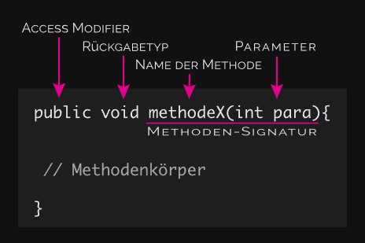JShell is (Shell) used to run Java Syntax

Every code-string is called “Method”

There are 2 type of Methods:

Method Head:

Method Body:

## **Simple Uses: More Options:**

Note:

With “.”, you can show the numbers after the commas.

## **Recall commands:**

With “$”, you can recall a specific line.

You can re assign a new value to a line $n with:

$1=5

-> the new $1 will be 5 and no more 4

## **Variable commands:**

With “var … = ” you can rename a number, an equation or other variables.

For the Variable Name you can use: small- & big characters,

number only followed with another character:

You can re assign a new a variable to a old one with “x = n” 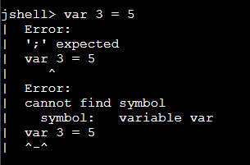

## **Conditions:**

* Less than: a < b
* Less than or equal to: a <= b
* Greater than: a > b
* Greater than or equal to: a >= b
* Equal to: a == b
* Not Equal to: a != b
* Between: buchstabe >= ‘a’ && buchstabe <= ‘z’

Result are “true” or “false”

“!” heißt nicht

!(x > 40) noch ein Beispiel

17 % 5 heißt modulo von (oder rest von)

Modulo works only with Integral Numbers, all the digits after the point will be printed back.

=> 2 weil die 5 passt 3 mal in die 17, mit rest 2

Operator: Modulo [%]

11 % 4 = ?

—> 11 – (11 / 4) * 4 = 11 – 8 = 3

11 % -4 = ?

—> 11 – (11 / -4) * (-4) = 11 – 8 = 3

-11 % 4 = ?

—> -11 – (-11 / 4) * 4 = -11 – (-8) = -3

-11 % -4 = ?

—> -11 – (-11 / -4) * (-4) = -11 – (-8) = -3

(!) der Vorzeichen der erste Operanten entscheidet der Vorzeichen des Ergebnisses

Structure

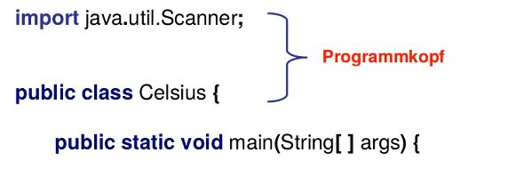

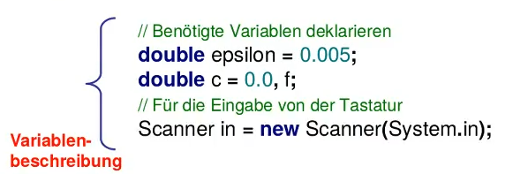

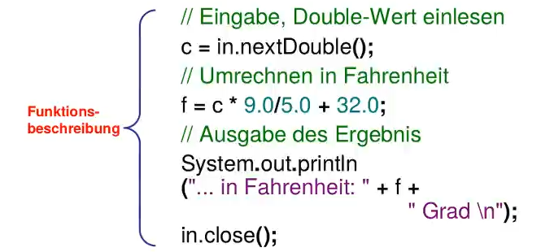

**Konstanten**:

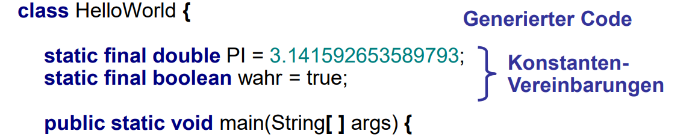

## Syntax

**Enumerations**:

Names for Constants, should be written BIG and separated with _.

MIN_MAX

MAX_VALUE

PI

And for constant’s group, use a literal abbreviations:

M_START M for Machine

M_STOP

WC_WHITE LC for Lightning Colours

WC_BLUE

WC_PURPLE